**PROJECT DESCRIPTION**

**PROJECT NAME**:INFORMATION PORTAL

This webpage consists of 6 different pages:

1. Home

2. About Us

3. Contact Us

4. Login

5. Feedback

6. Registration

**HOME:**

The home shows basic information.

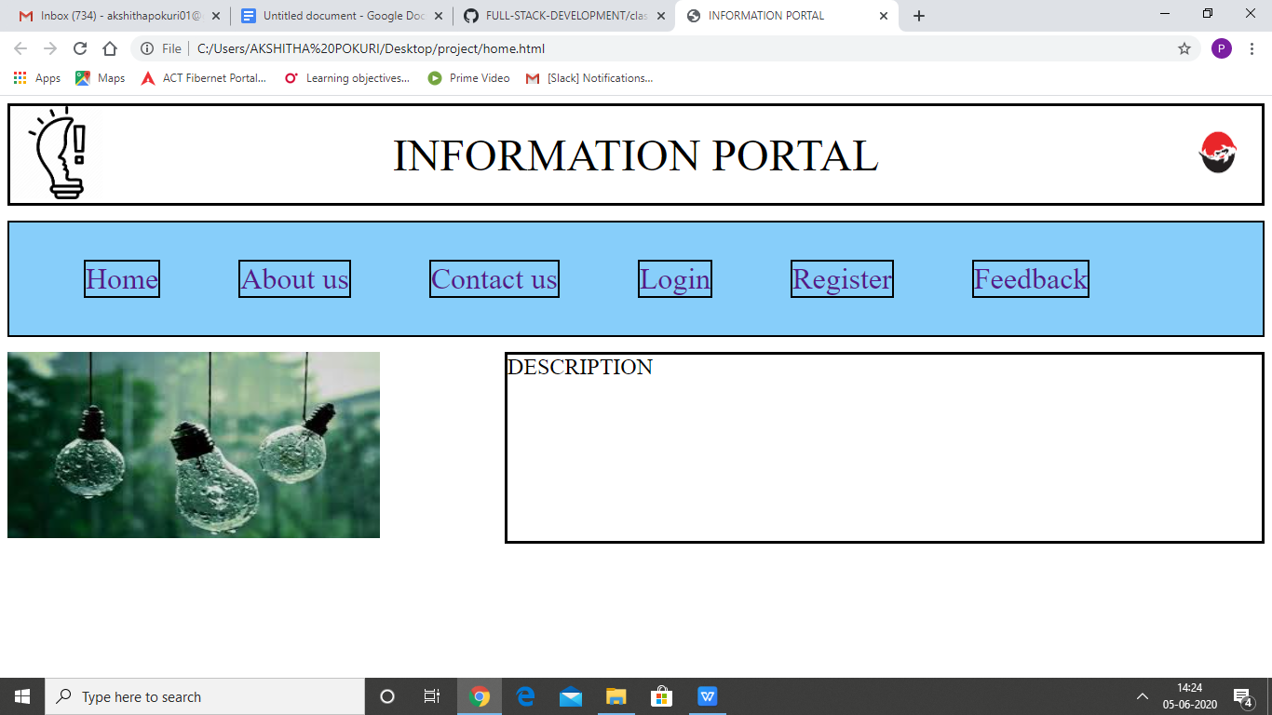

**ABOUT US:**

I have put this page basic and blank.

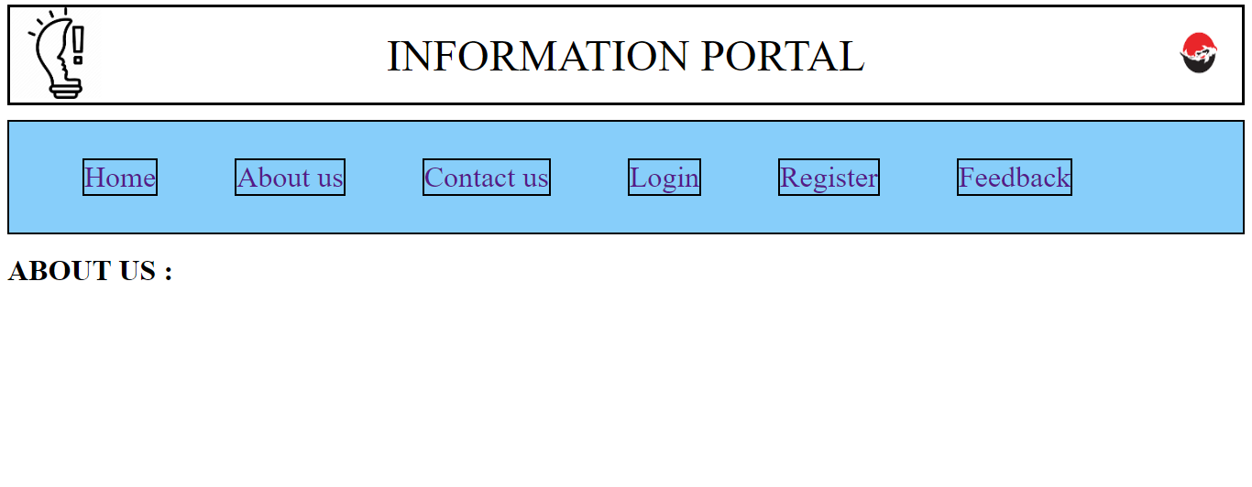

**CONTACT US:**

I have put this page basic and blank.

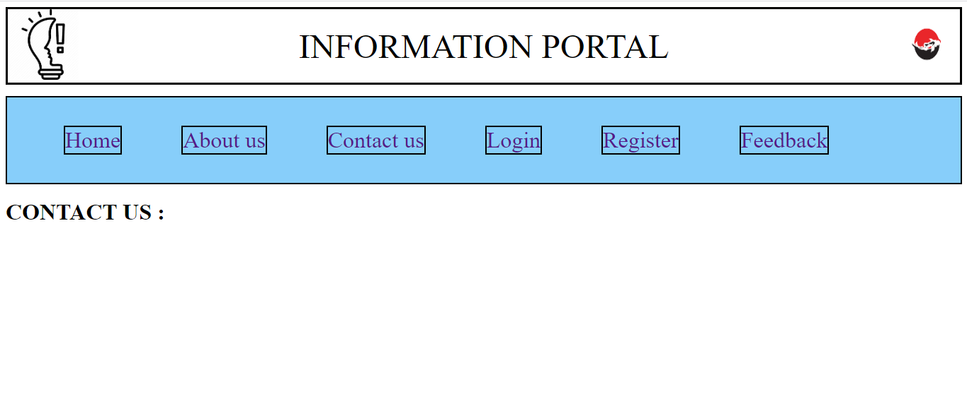

**LOGIN**:

This page is mainly for the staff or the members who already have an account . Here java script is used to validate username and password. Username is a 12digit pin number which is validated using a regular expression and password i(without quotes).Submit button is also validated using regular expression.

For Example:

Username:(roll number)

Password: (gitam123)

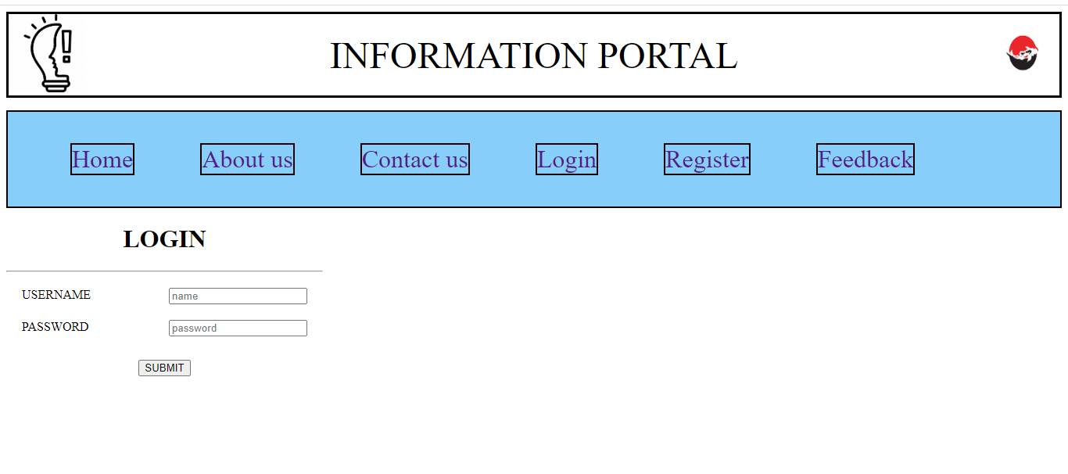

**REGISTER:**

This page is used to collect the details of the candidates who are willing to join the course and build a good resume and register here by filling all the necessary details which are asked in a particular way without having any errors.

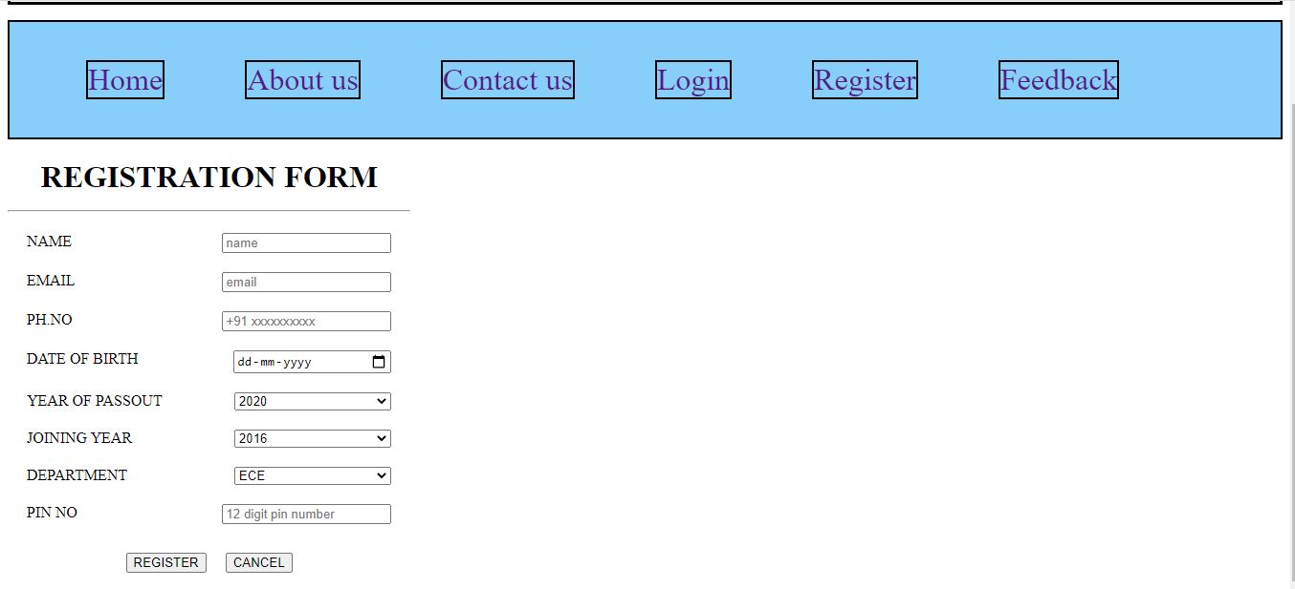

**FEEDBACK:**

After providing or at the time of providing the course each and every individual are encouraged to give feedback on the quality of service provided by us to them.

In this page email id, pin number and phone number are validated using java script and regex and there will be successful completion of feedback if the form is filled accurately as asked without any errors. And on clicking the submit button it shows a green colour tab which displays weather the feedback submission is successful or not.

This feedback helps to rate our self and also improve the standard of services provided by us.

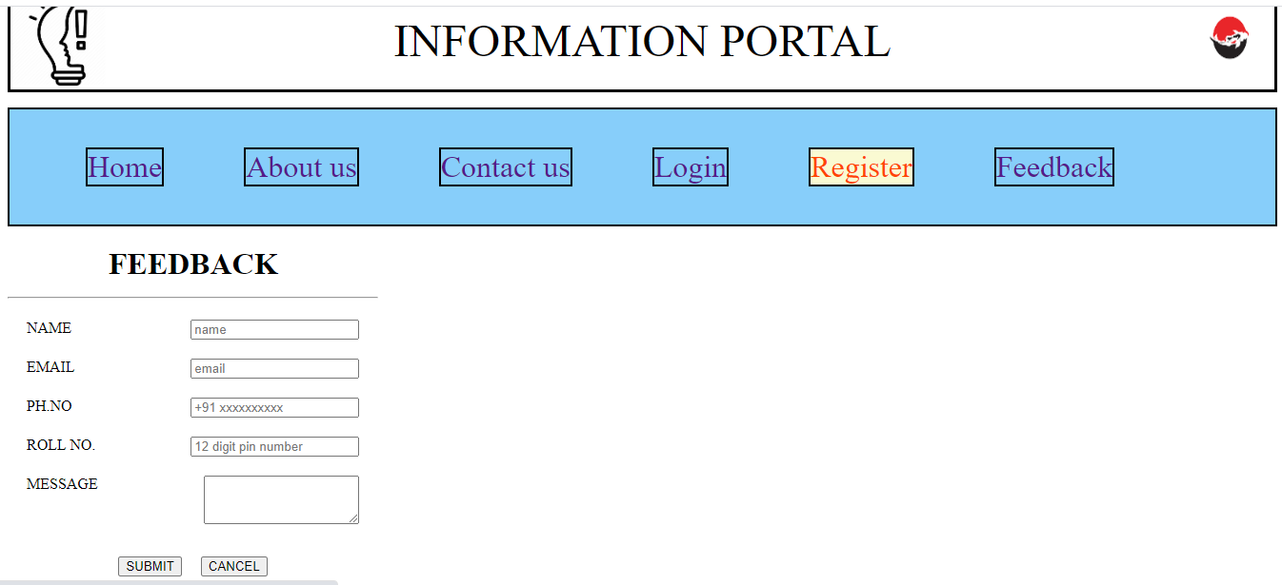

THANK YOU